

**Technical Manual**

Leonardo Gizzi, Cristiano De Marchis, Giacomo Severini

This document contains instructions and schematics for the mechanical and electrical assembly of the BENCH apparatus, as well as the description of the protocols for a proper use of the testbed and the software. It is intended as a self-sufficient guide, but please do not hesitate to contact the Authors in case of necessity.

Contacts:

LEonardo Gizzi - [gizzi@imsb.uni-stuttgart.de](mailto:gizzi@imsb.uni-stuttgart.de)

Cristiano De Marchis - [cristiano.demarchis@uniroma3.it](mailto:cristiano.demarchis@uniroma3.it)

Giacomo Severini - [giacomo.severini@ucd.ie](mailto:giacomo.severini@ucd.ie)

**Content**

**Disclaimer** **3**

**Motivation and Design Criteria** **4**

Construction 5

Connection 5

Software 5

**Materials and Assembly** **6**

What’s in the box 6

What’s not in the box 6

Mechanical assembly 7

Electrical assembly 13 Available Configurations 18

Protocols and testbed use 19

Testbed adjustments 21

Software instructions 22

Software Installation 22

Usage 22

**Bill of Materials**29

## Disclaimer

The BENCH apparatus has been designed to best adhere to the EuroBENCH criteria, however, this does not represent a complete guarantee of safety. We recommend our users to rely on common sense and get to know the testbed before use. The BENCH consortium will not be held responsible for damages or malfunctioning directly or indirectly connected to the use of the testbed and the provided software routines.

## 

## 

## Motivation and Design Criteria

BENCH is an instrumented testbed for the assessment of Sit-To-Stand performance in individuals wearing an exoskeleton/orthosis/prosthesis and humanoid robots. The aim of the testbed is to provide an objective, reliable and user-friendly measurement of the Sit-To-Stand performance in its two clinically most widely-adopted variants (the 5 Sit-To-Stand and the 30-seconds Sit-To-Stand, see section Protocols and testbed use).

The testbed is composed of an instrumented ground/chair system equipped with force plates, and synchronized with body-worn inertial measurement units (IMUs). BENCH is ready for integration with motion capture (MOCAP) and electrophysiological measurements systems; it complies with the EUROBENCH requirements (e.g., non-conductive elements[1], facility-compatible form factor, one-person operation, easy placement and adjustment and so on).

#### Construction

The measurement system consists of two force plates, one of which is mounted on the ground, the other on a height-adjustable seat. The seat is completed by a pair of adjustable handrails, and a removable back rest.

To grant maximal stability, the testbed is anchored to the ground by means of metal screws, and its height can be adjusted between 30 and 58 cm (see Testbed adjustments sections for detailed information).

In order to minimize the risks of short-circuits and electromagnetic disturbances, the body of the testbed is built in **PA6 Nylon[2]**.

The body of the testbed is modular and can be assembled and disassembled with commonly-available tools and minimal a-priori knowledge (see the Mechanical assembly section). Each component can be built with subtractive manufacturing technologies that are relatively common.

#### Connection

The sensor data from the force plates is collected through a USB A/D converter and synchronized with the outcomes of the Inertial Measurement Units (IMUs) provided with the system (see Electrical assembly).

#### Software

The synchronized data is transferred from a publisher machine (which is responsible for acquiring and sending the data) to a subscriber (which is receiving the data as ROS messages to different topics).

The subscriber is responsible for saving the raw data and providing the calculated metrics (see Software instructions).

## Materials and Assembly

#### What’s in the box

The package contains:

• 2 x BTS force plates (see datasheet for further information 1)

• 1 x NI USB-6218 A/D card (see datasheet for further information 2)

• 1 x seat

• 4 x leg

• 4 x stainless steel leg shoe

• 4 x back spine

• 1 x back rest

• 4 x handrail bottom

• 2 x handrail middle

• 4 x handrail top

• 2 x force plates

• 4 x single

• 1 x modified car jack + link

• 2 x load sensors (4 sensors + circuit board)

• 2 x side metal plates

• 1 x back metal plate

• 2 x 6cm rubber plate

• 2 x 8cm rubber plate

• 1 x 12cm rubber plate

• 24 x M4 x 70 mm

• 4 x M4 x 70 mm (longer threaded)

• 16 x M4 x 50 mm

• 24 x M4 x 15 mm

• 18 x M4 x 20 mm

• 5 x M4 x 130mm threaded bars

• 36 x M4 nuts

• 20 x M4 washers

• 4 x M3.2 x 20mm (circa) cut Parker screws

• 2 x vacuum holders

#### What’s *not* in the box

The following components (that are not necessary for the BENCH testbed to function, but that would grant its optimal use) are not included with the delivery package, as it was more complicated and expensive to shipt them, rather than to have them manufactured directly at the Facility in Madrid. They are reported here, but this section will be removed as soon as the manufacturing process is complete.

1 x Ground plane (a plate of laminar wood 1500x1500x18 mm long), a detailed design is included with the technical drawings of the device

5 x Ground support (wooden blocks of 150x150 mm), detailed designs are included with the technical drawings of the device

### Mechanical assembly

In the following section, the mounting process is reported. Some steps are optional and are indicated with a *. Optional means that when you receive the prototype, they may have already been done for you.

Tools you are going to need:

• M10 Allen key

• One M4 Allen Key

• One Medium-size Phillips screwdriver

• One pair of pliers

Before you start, take a moment to look at Figure 1, representing the top view of the seat. Familiarize with the names of the components to make sure you follow the instructions more easily.

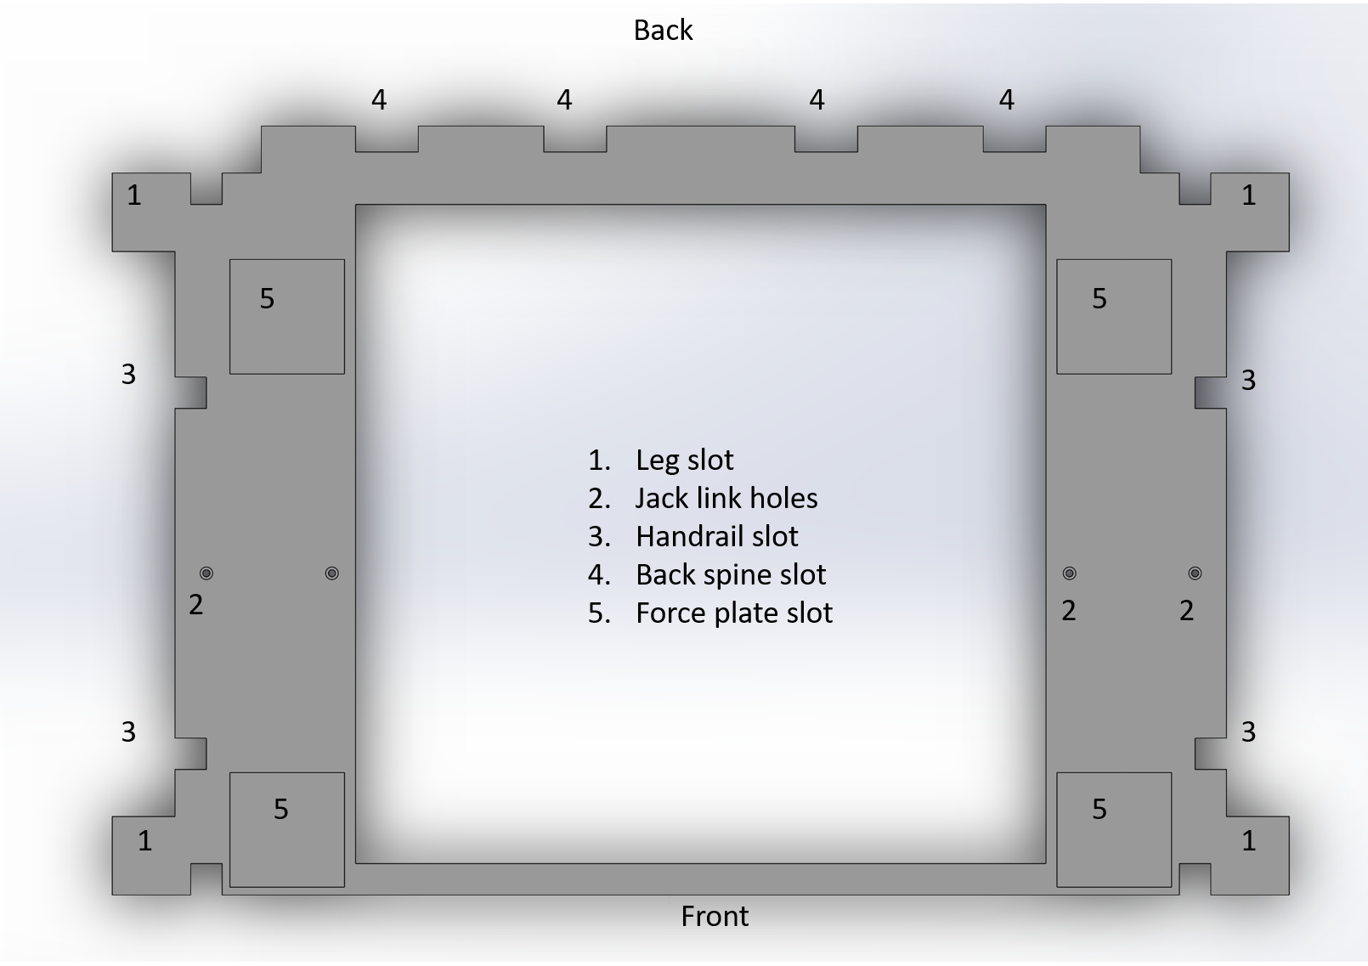

Figure 1

Step1: *Mount side metal plates* * (This step is most likely already done, if small metal plates are mounted on the sides of the seat, skip this step - If this is not the case, please keep reading) (Figure 2). Mount the metal plates on the side by means of the M4x15mm screws. You are going to need 12 per side (24 in total). Please check carefully the length of the screws and avoid using the M4x20mm (you will need them for mounting the back plate on step 8).

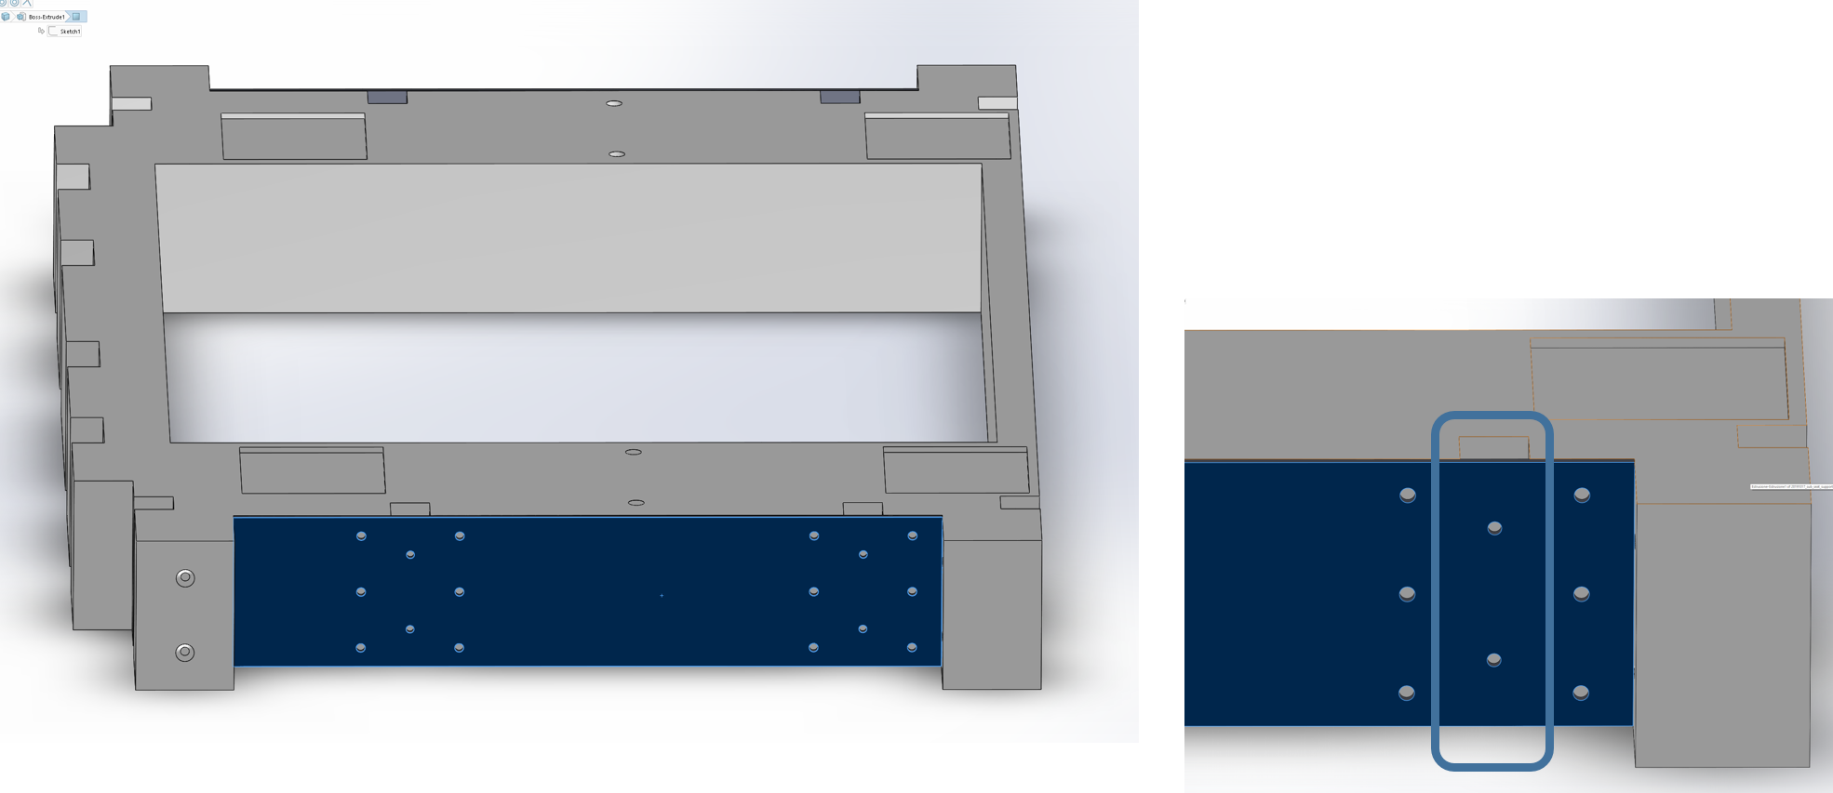

Figure 2

Step2: *mount the M10 T-nuts on the bottom of the ground panel*. Drill a 10mm diameter hole in the panel and place the nut on the bottom side, so that the spikes face the wood panel. Pull the nut with the M10 screw, so that the spikes enter the wood and secure the nut in place. (further information can be found here https://www.youtube.com/watch?v=HVfkxJiqLkA). Once you are done, place the panel on the floor in its final position. You may want to fix the panel on the floor.

Step3: *Mount the metal shoes for the legs*. Place each leg in correspondence to a hole in the ground panel (see Figure 3). Let one M10 bolt inside the shoe and screw it until completely fastened.

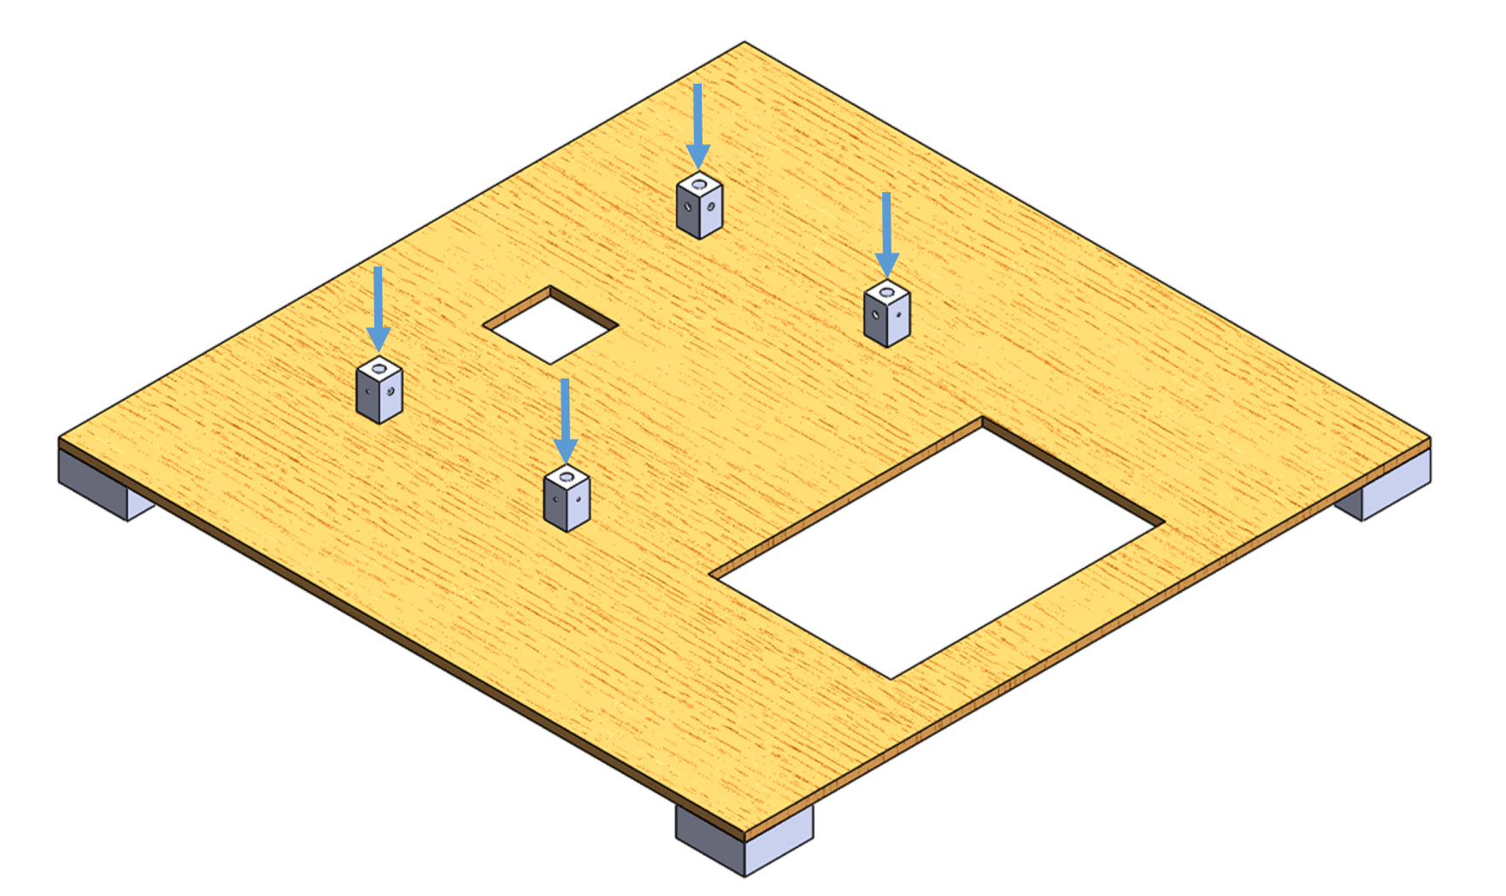

Figure 3

Step4: *Position the bottom force plate* (Figure 4) and arrange the cable so that it comes out from the back of the ground panel. Connect the cable on to the bottom of the force place, let the loose end of the cable in the hole of the panel and let it get out from the back. Use the vacuum holders to gently let the force plate fall in place paying attention that it does not lean on the cable.

Step5: *Mount the legs*. Flip the seat (bottom side facing up) and push the legs in place (steps 1 and 2 figure 7). There is no specific order as the legs can only fit in the correct direction and each leg can fit any slot. Fix the legs with M4x70 screws (they will fall in place without the need of screwing, if the legs are properly aligned). Please note that the legs slots have only two holes: the holes in the front slots are facing front, the holes in the back are facing sideways.

Step6: *Mount the seat and legs on the shoes*. Flip the seat and legs (top facing up) and let the legs fit around the shoes, fasten the shoes to the legs via Mx70 bolts and M4 nuts (step 3 in Figure 4).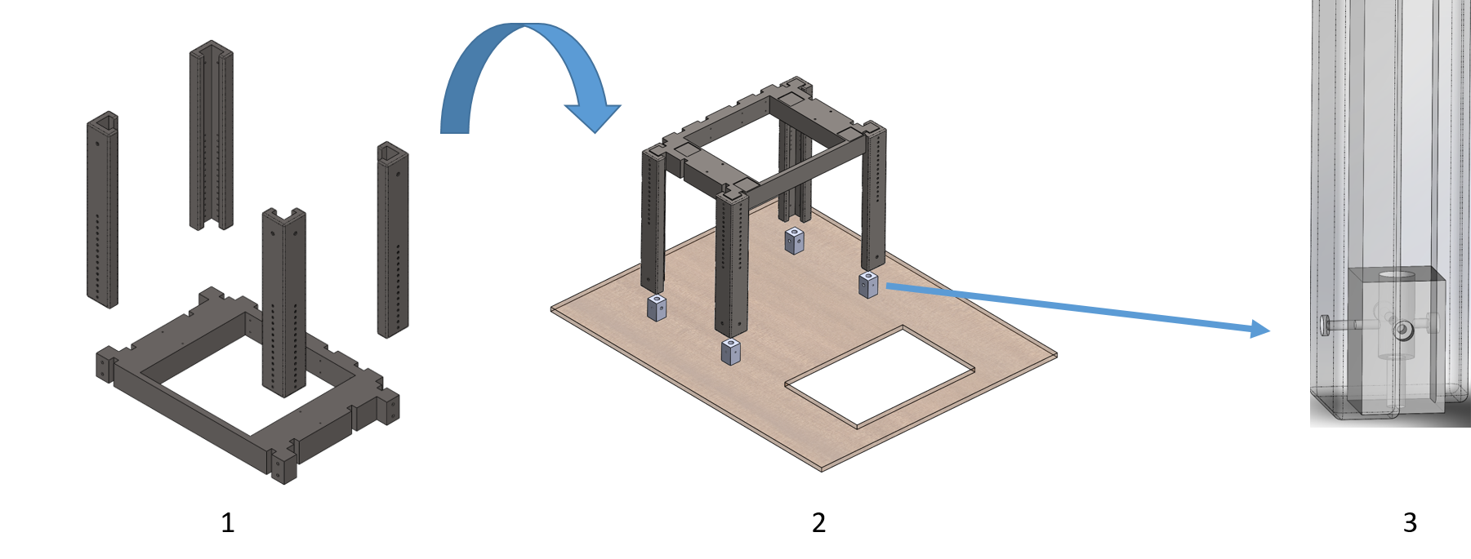

Figure 4

Step7: *Mount the back spines* (Figure 5, step 1). Carefully slide the back spines into their slots (in the back portion of the seat). The exposed-aluminum portion goes in the slots. Slide them horizontally (rather than vertically), as they are meant to fit quite tightly. Test the alignment of the holes with two M4x70mm screws (Figure 5, step 2). They should move through the holes effortlessly. Remove the screws before proceeding.

Step8: *Mount the back steel plate and the rubber plates* . With the spines already in place, mount the metal back plate with the M4x20mm screws (you are going to need 18 of them). Place the rubber pieces between the seat and the inner part of the metal plate. Mind that there the pieces have a specific position: the 12cm one goes in the middle, the 8cm ones go at its left and right, the 6cm ones go in the remaining length. Fasten the M4x20mm screws and then fasten the M4x70mm ones through the spines and the seat. Close them with a M4 bold and a washer.

Step9: *Mount the back rest* (Figure 5, step 3). Use 8 M4x50mm screws to fasten the back rest to the spines. Fasten the screws with bolts and washers.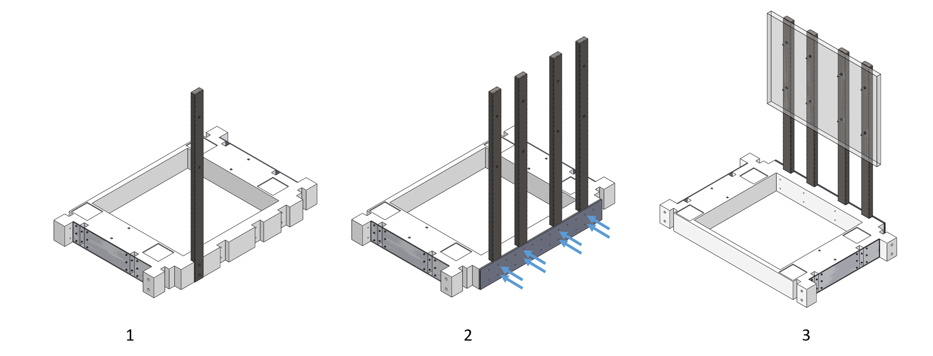

Figure 5

Step10: *Fix the jack* (Figure 6). Use 4 M4x130mm threaded bars, 8 nuts and washers to fix the metal bar connected to the jack to the bottom of the seat. Make sure that the top portion of the threaded bars is only slightly taller than the width of the nut, to make sure it doesn’t touch the bottom of the force plate, once you mount it.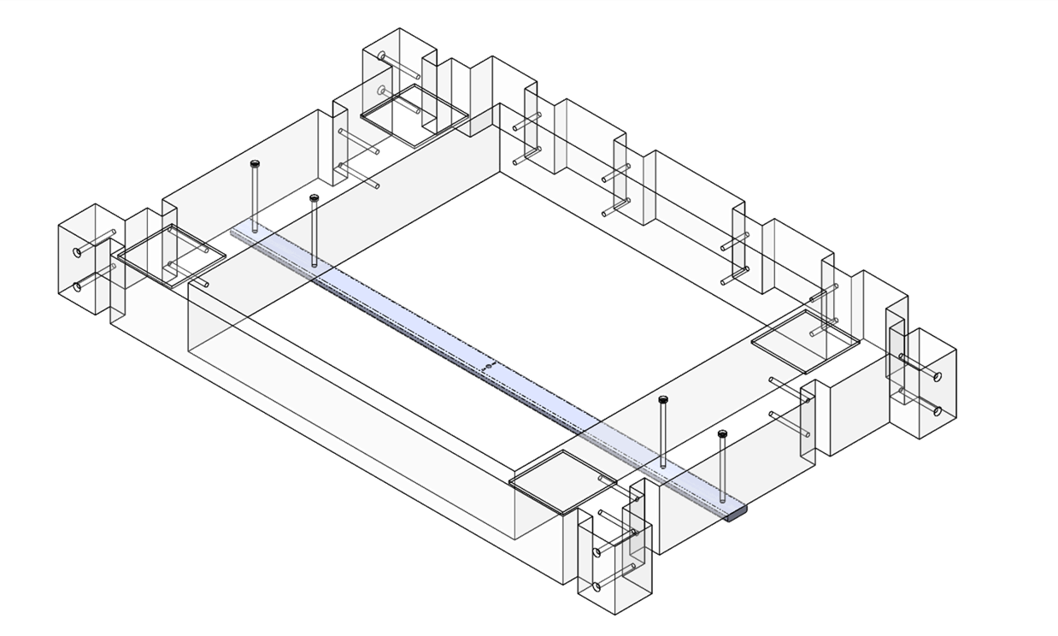

Figure 6

Step11: *Mount the seat force place* (Figure 7 upper part). Connect the cable on the bottom of the force place and let the free end pass through the seat frame and to the back hole in the ground panel. Lift the force plate with the vacuum holders and put it in place, so that the square-shaped feet fall into the respective slots on the seat.

Step12: *Assemble the handrails* (Figure 7 lower part, 6 steps).

1. Align the base of the handrail to the middle connector. Make sure that the holes are aligned properly (blue arrows) and that the base of the handrail is showing the widest side of the hole pointing outwards (steps 1 and 2). Fasten the two pieces tightly by means of the 3.2x20mm Parker screws. Repeat the process for the other side and for the other handrail.
2. Align the lower portion of the top of the handrail to the piece you have just assembled (steps 3 and 4). Use two (longer threaded) M4x70mm to reach the other side. Fasten the pieces using nuts and washers. Repeat for the other side. (b2)* Fix the load cell sensors with double sided tape, make sure that the cables and the PCB do not exceed the height of the sensors in any place. Repeat for the other side. (Technical specification regarding the load sensors and their connection can be found in paragraph 3.4)
3. Align the upper portion of the top of the handrail and fix it loosely with 4 M4x50mm screws (steps 5 and 6). Fasten them with nuts and washers. Make sure that the top of the handrail can move slightly and that you are not applying pressure to the sensors.

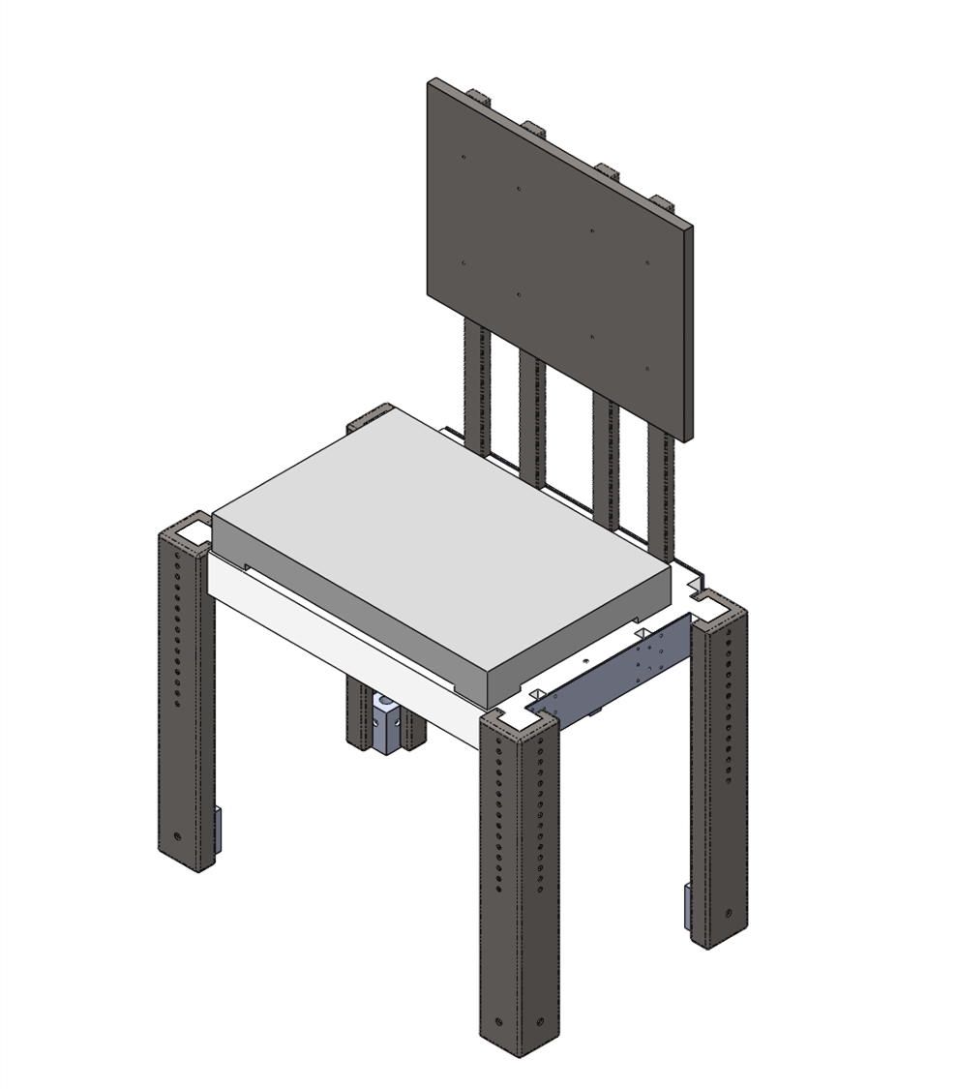

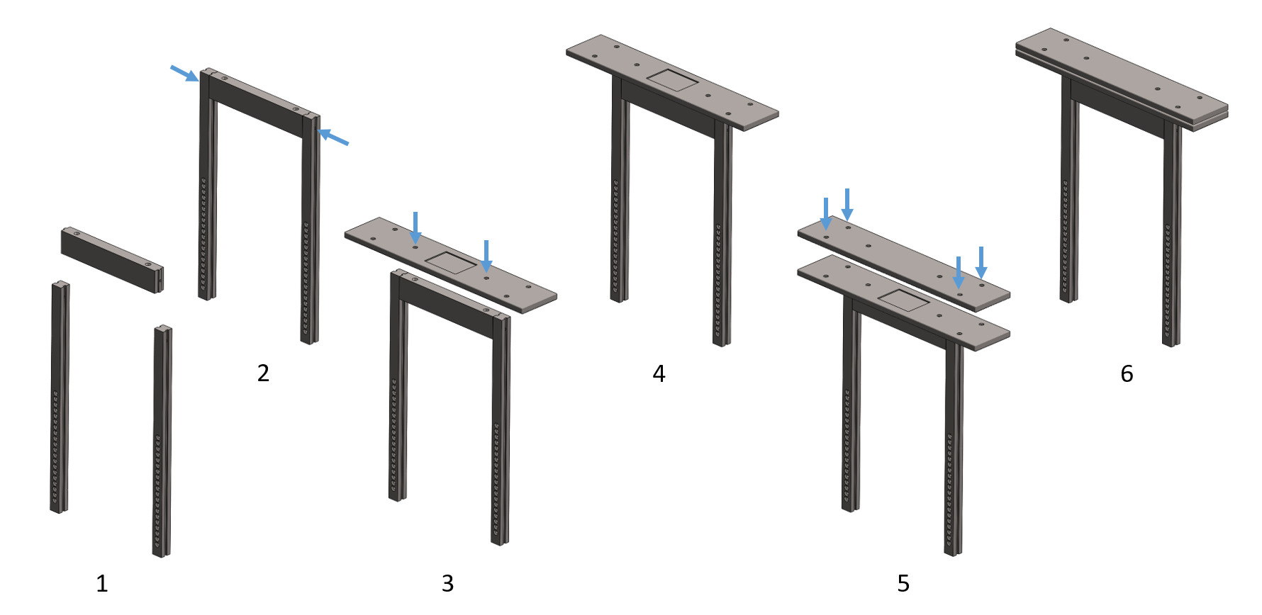

Figure 7

Step13: *Mount the handrails* (optional) (Figure 8 to control sequence). Slide the handrails in the handrail slot on the left and right sides of the seat. Pay attention that the wires are free and are oriented backwards. Let the wires pass through the back hole in the ground panel.

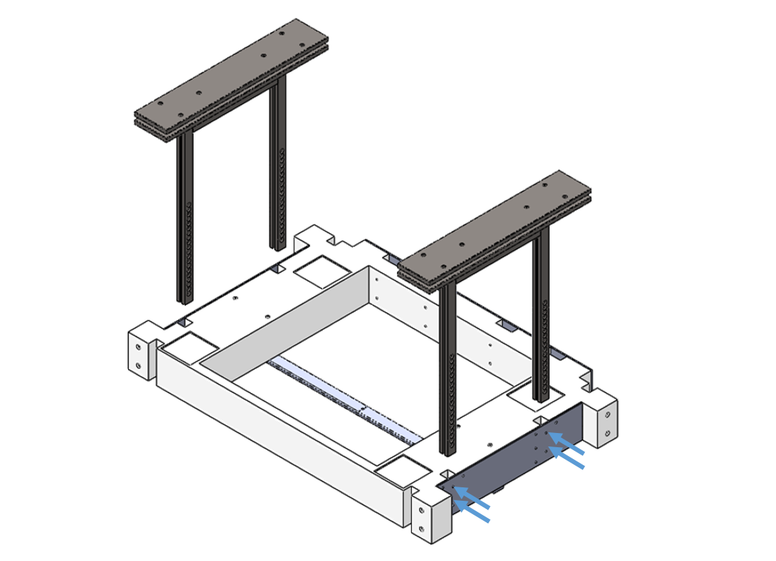

Figure 8

Step14: *Adjust the inclination of the force plates so that they are perfectly horizontal* (Figure 9). Use a spirit level (not included) to adjust the millimetric screws in the feet of the force plates.

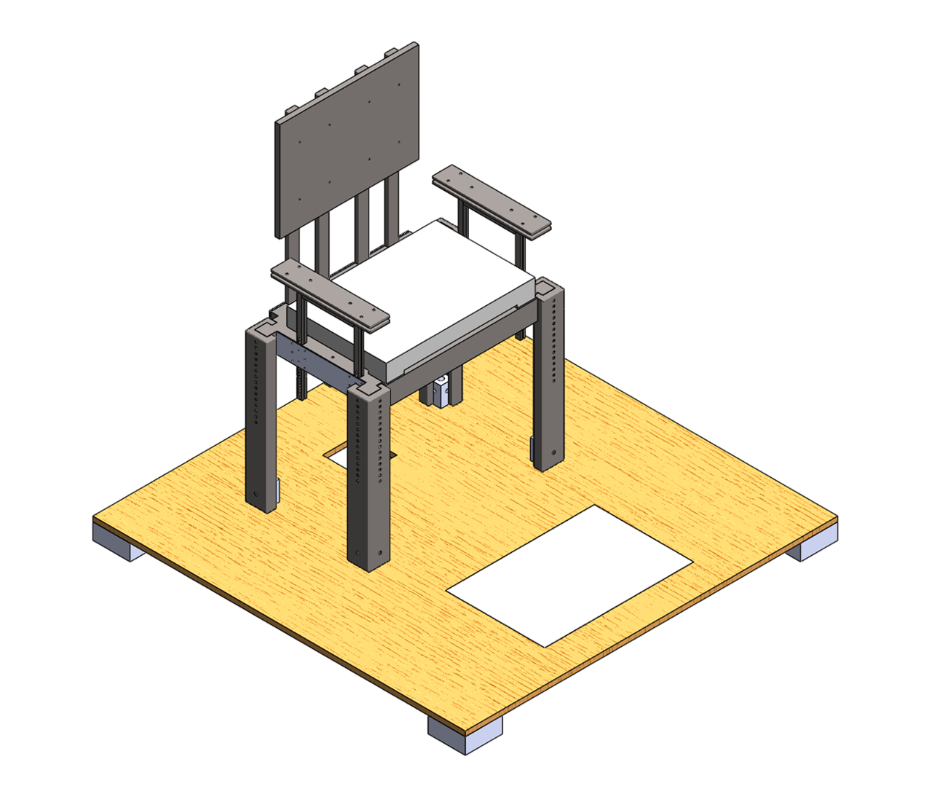

Figure 9

### Electrical assembly

In the following section, the process for assembling the electrical parts of BENCH is reported.

Tools you are going to need:

• 2 BTS force plates (with 2 signal cables with DB9M connectors)

• 1 BTS analog amplifier

• 1 NI-DAQ USB 6218

• 1 Trigger board

• 6 Shimmer sensors (5 IMUs + 1 IMU with EXG module)

Figure 10 shows the scheme for assembling the electrical parts of BENCH:

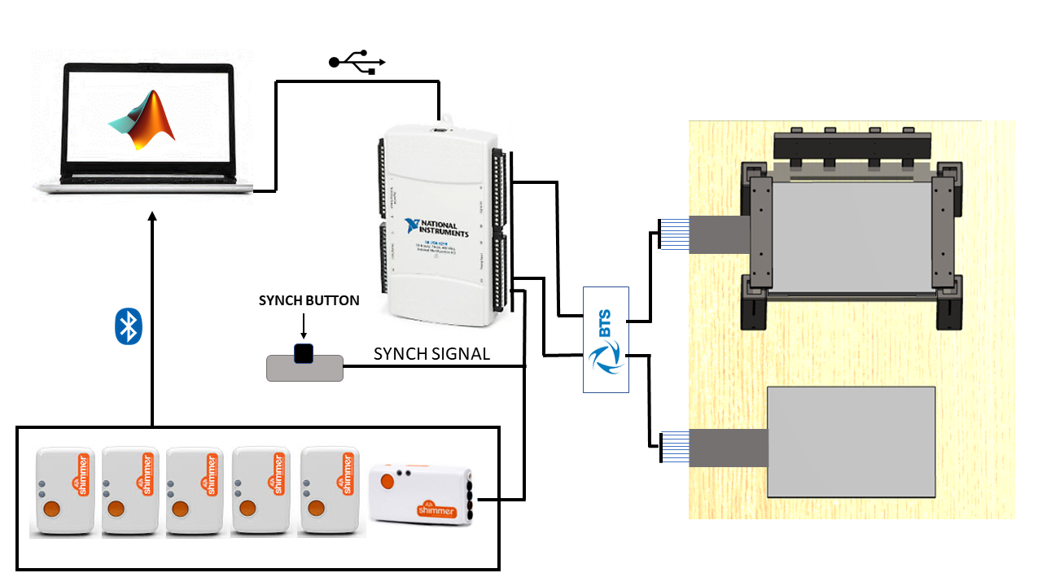

Figure 10

This section will be dedicated to the description of the connection of the force plates to the NI DAQ device, and to the explanation of the hardware synchronization board for obtaining a synchronized recording of the data from the IMUs and force plates.

*Connection of the force plates to the acquisition system:*

Step1: *Connect the cables with the DB9M connectors to the input of the BTS amplifier*. By convention, the seat force plate is Platform 1 and must be connected to the input 1 of the amplifier and the ground force plate is Platform2 and must be connected to the input 2 of the amplifier.

Step2: *Connect the amplifier output to the NI DAQ device*.

a) Predefined setup - connect the output of the amplifier to the NI DAQ device, using the two 2m long output C12015 shielded cables, according to the following cable order for the seat/ground force plates, respectively:

|  |  |
| --- | --- |
| Analog Input Channel | Color |
| AI1 / AI17 | White |
| AI2 / AI18 | Violet/Red |
| AI3 / AI19 | Blue |
| AI4 / AI20 | Gray |
| AI5 / AI21 | Green |
| AI6 / AI22 | Brown |
| AI7 / AI23 | Yellow |
| AI8 / AI24 | Pink |
| GND / GND | Black |

In this configuration, the input analog channel AI0 is reserved for the trigger signal coming from the synchronization board. In this configuration, the inputs from the two force plates are intuitively arranged on the opposite sides of the NI DAQ device for a more comfortable connection.

b) *explicit pinout, in case a different connection order is used (e.g. in case of channels malfunctioning that do not allow the use of the predefined setup) this is the pinout of the cables

|  |  |
| --- | --- |
| Component | Color |
| Fx12 | White |
| Fz1 | Violet/Red |
| Fz2 | Blue |
| Fz4 | Gray |
| Fy14 | Green |
| Fx34 | Brown |
| Fy23 | Yellow |
| Fz3 | Pink |
| GND / GND | Black |

from which the force, moment and CoP components are calculated according to the following equations provided by the constructor:

m_PlateA = 0.164;

m_PlateB = 0.264;

m_PlateZdX = 0.0225;

m_PlateZdY = 0.0225;

Fx = Fx12 + Fx34;

Fy = Fy14 + Fy23;

Fz = Fz1 + Fz2 + Fz3 + Fz4;

Mx = m_PlateB * ( Fz1 + Fz2 - Fz3 - Fz4 );

My = m_PlateA * ( -Fz1 + Fz2 + Fz3 - Fz4 );

Mz = m_PlateB * ( -Fx12 + Fx34 ) + m_PlateA * (Fy14 - Fy23);

Mya = My - Fx.*m_PlateZdY;

Mxa = Mx + Fy.*m_PlateZdX;

CoPx = -Mya./Fz;

CoPy = Mxa./Fz;

In case a configuration different from the predefined one is used, the pinout order must be declared as input to the Matlab function dedicated to data acquisition (*synch_acq.m*). An input option is dedicated to this choice (if no input is declared, the default configuration is used).

*Synchronization board*

This board enables the synchronized recording of the data coming from the BTS force plates described in the previous section and the data coming from the Shimmer sensors. The system uses an hardware synchronization which involves a continuous voltage signal, a voltage divider and a button driven electronic switch. The continuous voltage source is taken from the 5V output of the NI DAQ device and sent to the voltage divider, as shown in figure 11

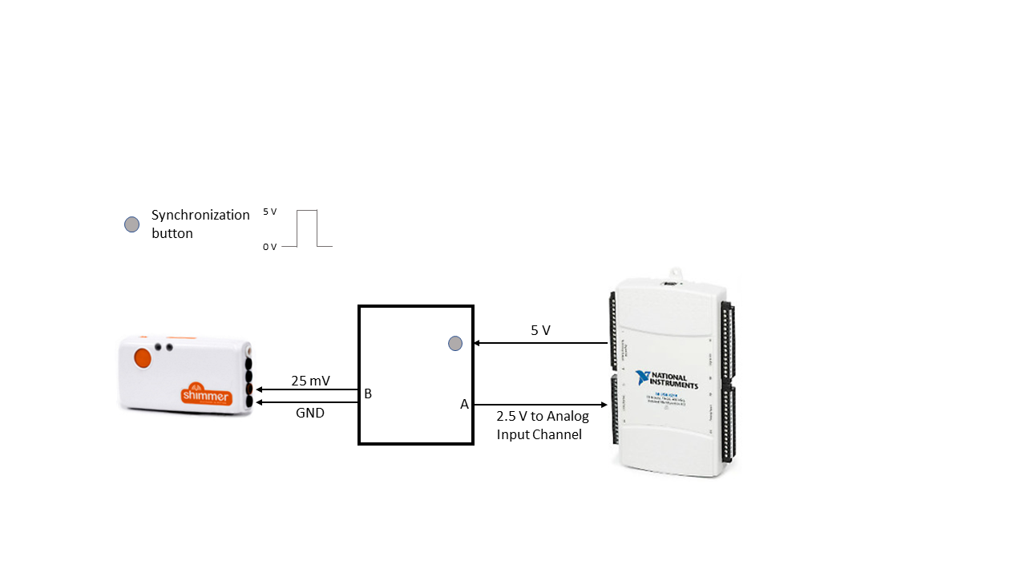

Figure 11

The trigger signal is taken from point A and sent back to the NI DAQ device analog input (~2.5V), and from point B and sent to the Shimmer unit dedicated to the synchronization (~25mV), using one of its two differential input channels (dedicated cables with a button clip edge are provided for connecting to the synchronization board). This last Shimmer unit is the only one equipped with an EXG acquisition board, able to acquire and amplify an input voltage signal (for recording ECG or EMG signals). This common trigger signal is used to synchronize the EXG Shimmer data with the NI DAQ data. The EXG Shimmer unit is synchronized with the other Shimmer sensors via software after the recording, using UNIX timestamps of each Shimmer unit (each Shimmer acquires signals independently from the others).

### Available Configurations

The module only contains one configuration.

The height of the seat, as well as the height of the handrails can be adjusted by the user (see Testbed adjustments).

### Protocols and testbed use

In this section, the two protocols that can be run with the BENCH apparatus, the 5 times sit-to-stand and the 30 seconds sit-to-stand, are described. Before the execution of a series of trials under both protocols, a calibration procedure is required for a proper estimation of the joint kinematics.

*Sensors placement:*

Five Shimmer sensors are required for the calculation of the ankle, knee, hip and trunk kinematics in the sagittal plane. The sensors must be placed over the foot, shank, thigh, lower back (~sacrum) and chest (~sternum) in an arbitrary orientation. A correct and tight placement of the sensors is facilitated by the use of comfortable wearable housings equipped with velcro straps. An additional Shimmer unit with an EXG board is placed on the BENCH device, working as a synchronization unit (as explained in the previous section) and as a marker of the chair orientation with respect to the laboratory (BENCH reference system).

*Calibration procedure:*

This procedure is used for a functional calibration of the sagittal plane for estimating ankle, knee, hip and trunk kinematics. The subject starts from a seated position, with a comfortably extended trunk, as shown in Fig. 12 a). In this procedure, the arms must be folded across the chest, and the subject must complete the movements in a clean way. Then the subject performs a series of basic movements to happen purely in the sagittal plane, as reported in the sequences from forward trunk bending b), to full standing c), hip extension d), and knee flexion e). The calibration procedure ends in the seated position f). Repeat the sequence twice, with a comfortable speed in order to control the different steps of the sequence and execute the different movements purely in the sagittal plane.

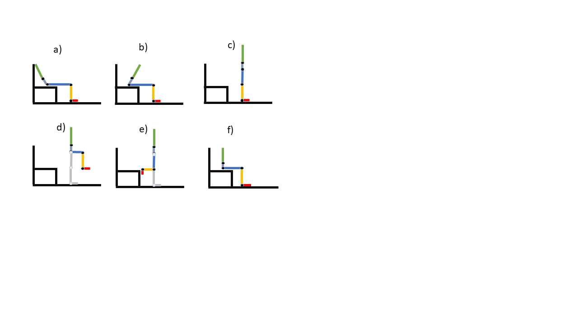

Figure 12

*Initial position and recommendations for both protocols:*

The protocol is completely administered on the BENCH testbed. It is generally recommended that the protocol starts with the subject leaning on the backrest of the chair, but depending on the subject height and on the testbed configuration (i.e. seat height), this recommended initial position is not mandatory and can be simply replaced with a seated comfortable position of the subject. The buttocks must be in contact with the seat, the feet must be in contact with the ground and the arms must be folded across the chest (with crossed wrists). It is recommended that the feet are kept symmetrical on the ground, and that the position of the feet does not change along the execution of the test. From literature, the recommended height of the seat is 43-45 cm from the ground, but the height of the seat is a controllable parameter for the execution of the test.

**5 times sit-to-stand (5STS)**

The five times sit-to-stand is a protocol for assessing the transfer skills when standing up and sitting down on a chair. The related performance indicators are linked to a general level of lower extremity strength, transitional movements, balance and fall risk, and have been shown to be correlated to the general mobility of a subject in everyday life.

*Test Execution:*

The subject is instructed to stand up and sit down 5 times as quickly as he can. The test starts when a GO signal is received. The test ends when the buttocks touch the seat for the fifth time, right after the fifth stand-to-sit movement. The subject must be instructed to stand fully after each sit-to-stand cycle. Moreover, the subject must be instructed to not touch the backrest between consecutive cycles (the only contact with the backrest should be the initial one). After the GO signal, the subject must execute the test without any external interference (e.g. incitation or pressure to go faster), since they could affect the PIs. The test can be administered as many times as the experimenter needs.

**30 seconds sit-to-stand (30sSTS)**

The 30 seconds sit-to-stand is a protocol for assessing the transfer skills when standing up and sitting down on a chair. The related performance indicators are linked to a general level of lower extremity strength, transitional movements, balance and fall risk, and have been shown to be correlated to the general mobility of a subject in everyday life.

*Test Execution:*

The subject is instructed to stand up and sit down as quickly as he can. The test starts when a GO signal is received. The test ends exactly after 30 seconds from the start. The subject must be instructed to stand fully after each sit-to-stand cycle. Moreover, the subject must be instructed to not touch the backrest between consecutive cycles (the only contact with the backrest should be the initial one). After the GO signal, the subject must execute the test without any external interference (e.g. incitation or pressure to go faster), since they could affect the PIs. The test can be administered as many times as the experimenter needs.

**General Guidelines:**

At the beginning of the recording the subject sits down in order to assume the starting position of the protocol, and the synchronization button is pressed. For subsequent data analysis purposes, when the recording is effectively finished by pressing the synchronization button, the subject must be in a sitting position without moving.

#### Testbed adjustments

Seat height adjustment:

1. Remove the pins that connect the legs with the seat
2. By means of the provided mechanical lifter (car jack) adjust the height of the seat to the desired value (between 30 and 50cm from the ground plane)
3. Place the pins back in their slots
4. (optional) for maximal stability, use the mechanical lifter to provide a light tension between the seat and the ground (be careful not to push/pull too strong, you may damage the pins of the plastic components!)

Handrails height adjustment:

1. Remove the pins that connect the handrails and the seat
2. Adjust the handrails to the desired height (between 20 and 40 cm from the seat plane)
3. Place the pins back in their slots

### Software instructions

#### Software Installation in the acquisition PC

Installation of the following Matlab Toolboxes is necessary:

* Data Acquisition Toolbox
* ROS Toolbox
* Shimmer Matlab instrument Driver

Installation of the following NI Software is necessary:

* NI MAX App ([Link to Download](https://www.ni.com/de-de/support/downloads/drivers/download.ni-daqmx.html#288283))

Installation of the following software is necessary for Shimmer calibration

* Consensys
* Shimmer calibration software

Installation of the following software is necessary for managing the communication between Shimmer sensors and Matlab

* Realterm serial terminal (<https://sourceforge.net/projects/realterm/files/Realterm/2.0.0.57/>)

#### Usage

There exists a publisher and a subscriber on two different machines.

The Publisher needs to open the matlab file *Main_Publisher* while the subscriber needs to open the matlab file *Main_Subscriber* . These instructions need to be followed to transmit the data:

1. Create the Master ROS node for the publisher with the script *Main_Publisher*. Type *rosinit* in the command line*.* The ROS master name which is displayed in the command window can be used later for connecting the subscriber to the ROS master.

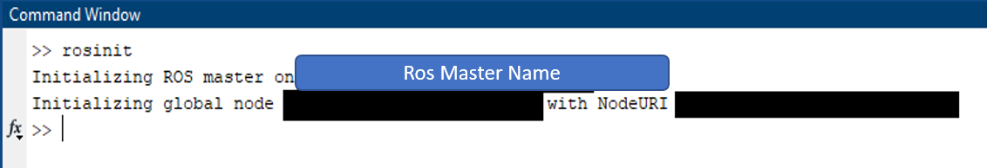

1. Enter subject number into field ENTER VALUES. Moreover, add the com ports of the shimmer sensors as cells made from strings.

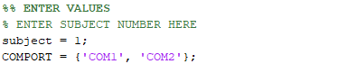

1. For connecting the subscriber to the publisher open the script *Main_Subscriber* andenter the ip address or the name of the ROS master that was created above as a string into field ENTER VALUES. Further, add the subject number.

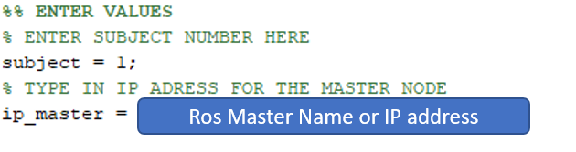

1. Start running the script of the subscriber. This needs to be done before the data is published. A GUI will open. Press the **Start Streaming** Button of the Subscriber. Do not close this window, it will be needed again!

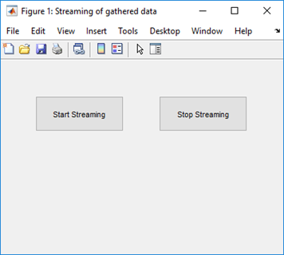

1. Then start running the script of the publisher for acquiring the necessary data. A figure window pops up as seen below. To stop the acquisition, click onto the window or push a key.

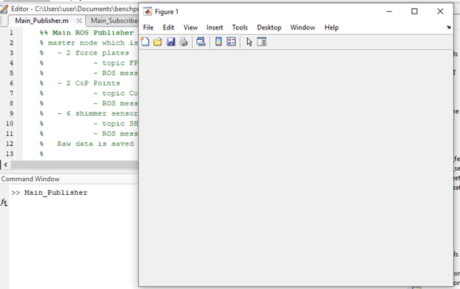

1. The figure is then closed, and the acquisition is stopped as well. The data will be sent automatically and is finally saved as raw data in a folder containing the subject number.

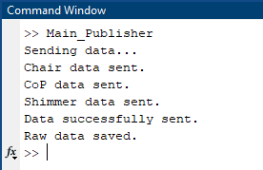

1. When successfully receiving the data, the subscriber gives information when reaching the last sensor by displaying how many seconds of data had been sent already. If no new seconds are added, everything is received, and the GUI can be used again to press **Stop Streaming**. The data is then saved in different files for each ROS topic in a folder with the subject number.

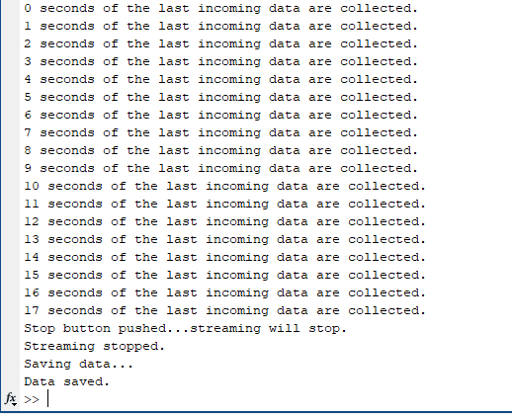

The data are collected by previously described the BENCH testbed, composed of two force plates and a set of 6 wearable sensors. After each trial, a csv file is generated containing the signals collected from all the sensors. The following data are collected and sent via ROS in the csv file:

1 time column common to all the signals

8 signals from the seat force plate (Fx, Fy, Fz, My, My, Mz, CoPx, CoPy)

8 signals from the feet force plate (Fx, Fy, Fz, My, My, Mz, CoPx, CoPy)

6 signals from each of the 6 wearable sensors (Ax, Ay, Az, Gy, Gy Gz)

The file is named “**Subject_(subjectnumber)_run _(trialnumber) _ {5sts, 30sts}_platformData.csv**”

e.g. “Subject_02_run_03_5sts_platformData.csv” is a file related to the third trial of the 5sts protocol executed by the subject02.

A total of 53 signals are thus included in the csv file received by the subscriber. All the data are organized in columns.

At the beginning of the whole session, a calibration procedure is needed to define the sagittal plane for the wearable sensors (previously described and graphically shown in figure 12). A single .csv file is generated at the end of this calibration procedure, containing the same data of a single sit-to-stand trial (i.e. 53 signals). The calibration procedure must be run only once, and it is valid for all the subsequent sit-to-stand protocols and trials.

The calibration file is named “**Subject_(subjectnumber)_calib.csv**”

According to the used protocol, a set of performance indicators are calculated (see the upcoming *Performance Indicators* section). The 5 times sit-to-stand protocol (5sts) and the 30 seconds sit-to-stand protocol (30sts) have a dedicated entry point, *computePI_5sts.m* and *computePI_30sts.m* respectively, receiving as input the trial file and the calibration file.

**Performance Indicators:**

The following 8 PIs are calculated from the protocols.

-----------------------------------------------------------------------------------------------------------------------------------

*PI1: 5STS duration* - it is calculated as the time elapsed between the first movement after the GO signal and the fifth dynamic contact with the chair (thus excluding the initial static contact). Data from both the Chair and lower limb kinematics are needed for calculating this PI. (this PI is calculated only under 5STS protocol)

Corresponding function: *sts_duration_5sts.m*

Recalled functions: *none*

-----------------------------------------------------------------------------------------------------------------------------------

*PI1: 30sSTS repetitions* - it is calculated as the number of full sit-to-stand cycles executed in the 30s after the GO signal. Only the data coming from the kinematics are used for calculating this PI. (this PI is calculated only under 30sSTS protocol)

Corresponding function: *repetitions_30sSTS.m*

Recalled functions: *none*

-----------------------------------------------------------------------------------------------------------------------------------

*PI2: STS subphases duration* - this PI consists of a 3 elements array of scalars indicating the average duration of each STS subphase. Each subphase duration is the average across the executed sit-to-stand cycles characterizing the protocol. The 3 phases are defined according to Caruthers et al. 2016, and based on the 4 time points:

- 1: t0: in each STS cycle, the start corresponds to the first trunk bending after the 0 velocity has been reached

- 2: lift-off: when the COP vertical force of the seat force plate goes to 0

- 3: maximum ankle dorsiflexion: corresponds to the point at which the shank bends over the foot, generating a maximum ankle dorsiflexion.

- 4: full hip extension: detected when the hip is fully extended, the sit-to-stand cycle ends. A subsequent beginning of the hip flexion identifies the beginning of the stand-to-sit cycle

These 4 points in each cycle lead to the following 3 subphases:

- Phase 1: Forward leaning

- Phase 2: Momentum transfer

- Phase 3: Extension

Data from both the Chair and kinematics are needed for calculating this PI.

Corresponding function: *segment_sts.m*

Recalled functions: *none*

-----------------------------------------------------------------------------------------------------------------------------------

*PI3: STS CoP stability* – this PI consists of a 2 elements array of scalars indicating the average distance travelled by the CoP both in AP and ML directions. Distance data are averaged across the executed STS cycles. Data from both the Chair and the output of PI2 are needed for calculating this PI.

Corresponding function: *sts_CoP_stability.m*

Recalled functions: *none*

-----------------------------------------------------------------------------------------------------------------------------------

*PI4: Time needed for unidirectional load transfer* – this PI is a single scalar indicating the time at which the average standing CoP position is reached during each sts dynamic transition (i.e. the lowest distance between the quiet standing CoP and the dynamic ground CoP). The data is averaged across the executed STS cycles. Data from both the Chair and the output of PI2 are needed for calculating this PI.

Corresponding function: *unidirectional_load_transfer.m*

Recalled functions: *none*

-----------------------------------------------------------------------------------------------------------------------------------

*PI5: Unidirectional load transfer overshoot* – this PI is an two elements array of scalars indicating the AP and ML unidirectional load transfer overshoot as the distance between the average standing CoP position and the local maxima of anteroposterior and medio-lateral CoP during sts transition. The data is averaged across the executed STS cycles. Data from both the Chair and the output of PI2 are needed for calculating this PI.

Corresponding function: *unidirectional_load_transfer.m*

Recalled functions: *none*

-----------------------------------------------------------------------------------------------------------------------------------

*PI6: kinematic repeatability* – this PI is a four-element array of scalars indicating the regularity of the ankle, knee, hip and trunk kinematics, respectively. Regularity is calculated through the normalized autocorrelation of the kinematics. In particular, for knee and hip the regularity corresponds to amplitude of the first peak of the normalized auto-correlation function at lag different from zero, while for the ankle and trunk it corresponds to the second peak. Only kinematic data are needed for calculating this PI

Corresponding function: *kinematics_repeatability.m*

Recalled functions: *none*

-----------------------------------------------------------------------------------------------------------------------------------

*PI7: total mechanical power* – this PI consists of a scalar indicating the total mechanical work done by the Center of mass. The CoM work is calculated as the scalar product between the CoM velocity and the force plates resultant force

Corresponding function: *tot_mech_pwr.m*

Recalled functions: *sts_CoM.m*

## Bill of Materials

|  |  |  |  |  |
| --- | --- | --- | --- | --- |
| Item Nr | Description | Unit cost (€) | Amount | Total (€) |
|  |  |  |  |  |
| 1 | Force Plate | 10000 | 2 | 20000 |
| 2 | Back Rest | 265 | 1 | 265 |
| 3 | Back Spine | 95,5 | 4 | 382 |
| 4 | Leg | 325 | 4 | 1300 |
| 5 | Handrail Bottom | 110 | 4 | 440 |
| 6 | Handrail Top | 115 | 2 | 230 |
| 7 | Seat | 1950 | 1 | 1950 |
| 8 | Handrail Load cell Support | 125 | 4 | 500 |
| 9 | Sub Seat Link | 145 | 1 | 145 |
| 10 | Cube Leg Support | 104 | 4 | 420 |
| 11 | Load Cell Sensor Circuit | 30 | 8 | 240 |
| 12 | Screw, Bolts, nuts (see materials list) | 100 | 1 | 100 |
| 13 | 64ch NI USB 6218 A/D Converter | 1300 | 1 | 1300 |
| 14 | Recording Laptop | 500 | 1 | 500 |
| 15 | Shimmer3 EXG | 450 | 1 | 450 |
| 16 | Shimmer3 IMU | 360 | 7 | 2520 |
| 17 | Consensys Base 15 EU | 680 | 1 | 680 |

1. The body of the apparatus, as discussed in the following, is non-conductive, however, as the commercial force plates that are used are made of metal, this requirement cannot be completely guaranteed. We invite the final users to pay attention whether or not their instrumentation may suffer for short-circuits due to the force plates.
2. https://en.wikipedia.org/wiki/Nylon_6